TITLE PAGE
Quantifying and Visualizing Pollution Dispersion using influencing factors
UG Project Report submitted in the partial fulfillment for the award of
……………………….
By
BADITHALA NAYAN PREETHAM
(Roll No.23065028)

Under the guidance of
Dr. Shweta Singh
Assistant Professor
Department of Civil Engineering, IIT (BHU)


Department of Civil Engineering
INDIAN INSTITUTE OF TECHNOLOGY
(BANARAS HINDU UNIVERSITY)
VARANASI – 221 005

21/04/2026

THESIS CERTIFICATE

This is to certify that the thesis titled Quantifying and Visualizing Pollution Dispersion using influencing factors, submitted by Badithala Nayan preetham (Roll No.23065028), to the Indian Institute of Technology (Banaras Hindu University), Varanasi, in the partial fulfillment for the award of Bachelor of Technology (B. Tech) in Civil Engineering, is a bona fide record of work done by him under my supervision. It is certified that the statement made by the student in his/her declaration is correct to the best of my/our knowledge.

Date of Submission:21/04/2026

Dr. Shweta Singh
Assistant Professor
Department of Civil Engineering,
IIT (BHU), Varanasi – 221 005

DECLARATION BY THE CANDIDATE

I, Nayan preetham, certify that the work embodied in this thesis is my own bona fide work carried out by me under the supervisions of Dr.shweta singh, from January, 2026 to April, 2026 at the Department of Civil Engineering, Indian Institute of Technology (BHU), Varanasi. The matter embodied in this thesis has not been submitted for the award of any other degree/diploma. I declare that I have faithfully acknowledged and/or cited to the researchers wherever their works have been utilized in this thesis. I further declare that I have not willfully copied any other’s work, paragraphs, text, data, results, etc., reported in journals, books, magazines, reports dissertation, thesis, etc., or available at websites.
.
Date: 21/04/2026 Signature
Place: Varanasi BADITHALANAYANPREETHAM
23065028

ACKNOWLEDGEMENT

I would like to express my sincere gratitude to my supervisor Dr. Shweta Singh
for his invaluable guidance, constant encouragement, and insightful suggestions throughout the course of this project. His expertise in environmental modeling and data science has been instrumental in shaping this work.
I am also thankful to the Department of Civil Engineering, IIT (BHU), Varanasi, for providing the necessary computational resources and academic environment. Special thanks to the faculty members who offered constructive feedback during the project reviews.
I acknowledge the data providers — ERA5 reanalysis and urban emissions , opentopography — whose open-access datasets formed the foundation of this research. The availability of these resources enabled the rigorous development and testing of the proposed model.
Finally, I extend my deepest appreciation to my family and friends for their unwavering support, motivation, and patience throughout the duration of this project.

ABSTRACT

Air pollution is a critical environmental issue requiring accurate prediction and understanding of pollutant dispersion. This project develops a data-driven spatio-temporal model to predict the Air Quality Index (AQI) using grid-based daily data over the Indo-Gangetic Plain region of India, one of the most polluted airsheds in the world.
The model integrates three key components: temporal dependencies through lagged AQI features; spatial dependencies using neighboring grid cell values and wind-driven advection; and meteorological parameters such as wind speed, wind direction, temperature, and planetary boundary layer height. A hybrid framework is implemented, combining machine learning (XGBoost and Random Forest ensembles) for local concentration estimation with a physics-constrained upwind transport scheme for pollutant advection. The transport module employs Courant-limited flux computation to ensure numerical stability and positivity preservation.
The model is evaluated on a 21×21 spatial grid (25°N–30°N, 75°E–80°E) over forecast horizons ranging from 15 days to one year. Results demonstrate that incorporating spatial transport significantly alters local AQI predictions. For a representative location (27°N, 78°E), the model predicts an AQI of 82.08 after 15 days, with identifiable upwind sources contributing +3.5 AQI units. The influence matrix reveals structured patterns of pollutant gain and loss across the domain, aligning with prevailing wind directions.
This work establishes that a computationally efficient hybrid ML-physics model can capture the essential dynamics of pollution dispersion without requiring detailed emission inventories or full Computational Fluid Dynamics simulations. The framework is suitable for operational air quality forecasting and policy decision support.
Keywords: Air Quality Index, Spatio-temporal modelling, Machine Learning, Pollution Dispersion, Grid-based Prediction, Hybrid Modelling.

TABLE OF CONTENTS

- Title Page
- Thesis Certificate
- Declaration by the Candidate
- Acknowledgement
- Abstract
- Table of Contents
- Introduction
- Literature Review
- Methodology
- Results and Discussion
- Conclusion and Future Work
- References
- List of Figures
- List of Tables

INTRODUCTION
1.1 Background and Motivation
Air pollution has emerged as one of the most critical environmental challenges of the modern era, particularly across the Indo-Gangetic Plain, where rapid urbanization, industrial activity, vehicular emissions, and seasonal agricultural practices have led to persistently high pollutant concentrations. Cities such as Varanasi, Kanpur, and Agra frequently exhibit hazardous Air Quality Index (AQI) levels, posing severe risks to public health.
The AQI serves as a normalized indicator that aggregates multiple pollutants into a single interpretable scale. While measurement of AQI is well established, the real challenge lies in forecasting its evolution across both space and time. Accurate prediction is essential for issuing health advisories, planning mitigation strategies, and understanding pollution dynamics.
From a physical perspective, pollutant transport is governed by advection–diffusion processes, where concentration evolves under atmospheric motion and dispersion. Mathematically, this is expressed as:
1.2 Problem Statement
Given a gridded AQI dataset along with associated meteorological variables, the problem is to predict the spatial distribution of AQI over future time steps while explicitly accounting for pollutant transport between regions.
The challenge lies in constructing a model that satisfies key physical constraints:
- Positivity: AQI values must remain non-negative
- Approximate mass conservation across the spatial domain
- Interpretability of spatial interactions and regional influence
At the same time, the model must remain computationally feasible and applicable in data-limited environments.
1.3 Objectives
The objectives of this study are formulated to bridge the gap between physical modeling and data-driven approaches:
* To develop a spatio-temporal machine learning framework for AQI prediction using historical and meteorological data
* To model inter-regional pollutant transport using a physics-inspired advection mechanism
* To integrate machine learning and transport dynamics into a unified hybrid framework
* To ensure numerical stability and adherence to physical constraints
* To analyze spatial interactions through influence matrices and dispersion patterns
1.4 Scope and Limitations
The study focuses on a regional domain discretized into a regular spatial grid, where each cell represents an averaged AQI value. Temporal resolution is considered at a daily scale.
To maintain computational tractability, several simplifications are adopted:
* Emission sources are not explicitly modeled; instead, patterns are learned from historical data
* Transport is approximated as two-dimensional horizontal advection, neglecting vertical mixing
* Chemical transformations of pollutants are not explicitly included
* Meteorological inputs are derived from reanalysis datasets, which may not fully capture local variations
These limitations imply that the model emphasizes structural understanding and predictive capability rather than full atmospheric simulation.
1.5 Organization of the Report
The remainder of this report is structured as follows. Chapter 2 presents a review of existing literature, including physical dispersion models, machine learning approaches, and hybrid frameworks. Chapter 3 details the proposed methodology, including data processing, feature engineering, transport modeling, and model integration. Chapter 4 discusses the results, including prediction performance, dispersion analysis, and spatial influence patterns. Finally, Chapter 5 concludes the study and outlines potential directions for future work.

LITERATURE REVIEW

2.1 Physical Dispersion Models
Physical dispersion models simulate pollutant transport using governing atmospheric equations such as the advection–diffusion equation. The Gaussian plume model provides an analytical solution under steady-state conditions and is widely used due to its simplicity. Advanced models such as CMAQ and WRF-Chem simulate three-dimensional transport, chemical reactions, and turbulence with high accuracy. However, these models require detailed emission inventories, accurate boundary conditions, and high computational resources, making them impractical for large-scale operational use in data-limited regions.
References:
https://www.epa.gov/cmaq

2.2 Statistical and Machine Learning Approaches
Statistical models such as ARIMA and linear regression are computationally efficient and interpretable but fail to capture non-linear relationships and spatial dependencies. Machine learning models, including Random Forest and XGBoost, improve predictive accuracy by learning complex patterns from data. Deep learning models such as LSTM and ConvLSTM further capture temporal and spatial dependencies in AQI data. However, these approaches lack physical interpretability, may violate constraints such as non-negativity, and often do not explicitly model spatial transport mechanisms.
References:
https://dl.acm.org/doi/10.1145/2939672.2939785

2.3 Hybrid Physics–Machine Learning Frameworks
Hybrid approaches combine physical modeling with machine learning to improve both accuracy and consistency. Physics-Informed Neural Networks incorporate governing equations into the training process, ensuring physically consistent predictions. Other approaches integrate machine learning outputs with simplified transport models, such as coupling emission estimation with dispersion models. While these methods improve performance, they are often computationally intensive, lack numerical stability considerations, and are not designed for lightweight deployment.

References:
https://arxiv.org/abs/1711.10561
https://www.sciencedirect.com/science/article/pii/S1352231020302294

2.4 Research Gap Identification
Existing approaches reveal several limitations. Physical models are accurate but computationally expensive, while machine learning models are efficient but lack physical consistency and interpretability. Hybrid models exist but are often complex, computationally demanding, or lack explicit treatment of numerical stability and transport mechanisms.

There is a clear need for a framework that is computationally efficient, physically constrained, and interpretable. This study addresses this gap by developing a grid-based hybrid model that integrates machine learning with a simplified, physics-inspired transport scheme. The model enforces positivity, maintains approximate mass conservation, and provides interpretable spatial diagnostics such as influence matrices and dispersion patterns. Additionally, it enables quantitative evaluation of inter-regional AQI influence, offering insights into whether pollution is locally dominated or driven by transport processes.

METHODLOGY

3.1 Study Area and Data Description
The study domain spans latitudes 25°N to 30°N and longitudes 75°E to 80°E, encompassing parts of the states of Rajasthan, Uttar Pradesh, and Madhya Pradesh in northern India. This region includes major urban and industrial centres such as Jaipur, Agra, Kanpur, and Gwalior, and is characterized by significant seasonal variability in air quality driven by monsoon precipitation, post-harvest crop residue burning, and winter temperature inversions that trap pollutants near the surface.
Data were sourced from the following providers:
•AQI Data: Gridded daily AQI derived from satellite retrievals and ground monitoring station records, aggregated to a 21×21 grid at approximately 25 km resolution.
•Meteorological Data: Hourly fields from the ERA5 global reanalysis (Hersbach et al., 2020), including the 10 m zonal wind component (u10), 10 m meridional wind component (v10), 2 m air temperature (t2m), surface pressure (sp), total precipitation (tp), and planetary boundary layer height (pblh).
•Static Data: Terrain elevation and slope derived from the SRTM (Shuttle Radar Topography Mission) digital elevation model, resampled to the study grid.

Table 3.1 summarizes the data variables used in the study.
Variable | Description | Source
AQI | Air Quality Index (daily average) | Merged dataset
u10 | 10 m zonal wind component (m/s) | ERA5
v10 | 10 m meridional wind component (m/s) | ERA5
wind_speed | Derived wind magnitude √(u10²+v10²) | Computed
pblh | Planetary boundary layer height (m) | ERA5
t2m | 2 m air temperature (K) | ERA5
sp | Surface pressure (Pa) | ERA5
tp | Total precipitation (m/day) | ERA5
elevation | Terrain elevation (m) | SRTM
slope | Terrain slope (degrees) | Derived from SRTM

3.2 Data Preprocessing
Consistent preprocessing was applied to all datasets before model development. Missing values in the AQI time series, arising from satellite retrieval failures or station outages, were filled using linear temporal interpolation for each grid cell independently. All input variables were normalized to zero mean and unit variance prior to machine learning model training, with scaling parameters saved for use during inference to ensure consistency between training and deployment.
AQI values were clipped to a minimum background concentration of 1.0 throughout the simulation to prevent physically implausible negative values that can arise from numerical diffusion in the transport step. All meteorological variables were temporally aggregated from hourly to daily resolution using 24-hour averaging before being aligned with the AQI time series.
3.3 Feature Engineering
Features for the machine learning models were constructed to capture both temporal persistence and spatial context at each grid cell.
3.3.1 Temporal Lag Features
Lagged AQI values at t−1, t−2, and t−7 days were included for each grid cell. These features capture short-term persistence (the strong autocorrelation in daily AQI time series) and weekly cycles arising from weekday-versus-weekend emission patterns (e.g., reduced industrial and vehicular activity on weekends).
3.3.2 Spatial Lag Features
For each grid cell, the AQI values of its four orthogonal neighbours (north, south, east, west) at time t−1 were included as features. These spatial lag features allow the model to learn local dispersion patterns from the historical data, supplementing the explicit physics-based transport scheme with an implicit data-driven component.
3.3.3 Meteorological Features
The following meteorological variables at time t were included: u10 and v10 wind components, wind_speed magnitude, planetary boundary layer height (pblh), 2 m temperature (t2m), surface pressure (sp), and total precipitation (tp). In total, ten feature channels were stacked for each grid cell, forming a feature tensor of shape (21, 21, 10).
Table 3.2 lists the complete feature set.
Serial No. Feature Description
1 AQI at time t−1 (normalized)
2 u10 — 10 m zonal wind component
3 v10 — 10 m meridional wind component
4 wind_speed — derived magnitude
5 pblh — planetary boundary layer height
6 t2m — 2 m air temperature
7 sp — surface pressure
8 tp — total precipitation
9 elevation — terrain elevation
10 slope — terrain slope
3.4 Graph Construction and Edge Weights
To model pollutant transport between grid cells, a graph representation of the spatial domain was constructed. Nodes correspond to the 441 grid cells in the 21×21 domain. Directed edges connect each cell to its eight neighbours (four orthogonal and four diagonal), yielding a sparse graph with approximately 3,400 edges after boundary conditions are applied.
Edge weights wᵢⱼ quantify the ease of pollutant transport from node i to node j based on wind alignment and elevation gradient. The weight is computed as:
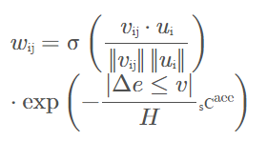
where vᵢⱼ is the unit vector from node i to node j, uᵢ is the wind vector at node i, σ is a sigmoid scaling function mapping cosine alignment to [0,1], Δelev is the elevation difference between cells i and j, and Hₛᴄᵃᵉᵉ = 200 m is a characteristic scale height. Weights approach zero for edges pointing strongly upwind or traversing steep terrain, ensuring that transport is physically directional.
3.5 Physics-Based Transport Module
The transport module updates AQI values at each time step by moving pollutants along graph edges according to wind-driven advection. Three design principles govern the implementation.
3.5.1 Upwind Advection Scheme
An upwind (donor-cell) advection scheme is employed, in which the flux from cell i to cell j is proportional to the AQI concentration in the source cell i rather than in the destination cell j. This choice ensures that information propagates in the physically correct downwind direction and avoids the instabilities associated with centred-difference schemes at high Courant numbers.
3.5.2 Courant-Limited Flux Computation
To guarantee numerical stability, the flux fraction transferred per time step is limited by the Courant-Friedrichs-Lewy (CFL) condition. The CFL number at node i is computed as:
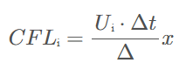
where Uᵢ is the wind speed magnitude at node i (m/s), Δt = 86400 s (one day), and Δx = 25,000 m (grid spacing). The flux coefficient for each edge is then capped at 0.5, ensuring that no grid cell loses more than 50% of its pollutant mass to outflow in a single time step, which guarantees positivity preservation.
3.5.3 Positivity Preservation
After computing net inflow and outflow for each cell, the updated AQI is clamped to a minimum background concentration of 1.0 AQI units, representing the clean-air background level below which the model is not expected to produce meaningful predictions.
3.6 Machine Learning Models
Two ensemble tree models were independently trained on the 10-channel feature vectors described in Section 3.3, and their predictions were combined via weighted averaging.
3.6.1 XGBoost Regressor
XGBoost (eXtreme Gradient Boosting) is a scalable gradient boosting framework that constructs an ensemble of weak learners (shallow decision trees) sequentially, with each tree trained to minimize the residuals of the previous ensemble. L1 and L2 regularization terms are incorporated into the objective function to control model complexity. Hyperparameters — learning rate = 0.1, max_depth = 6, n_estimators = 500 — were selected via five-fold cross-validation on the training set.
3.6.2 Random Forest Regressor
Random Forest constructs an ensemble of fully-grown decision trees on bootstrapped samples of the training data, with feature subsampling at each node split to de-correlate the individual trees. Averaging the predictions of 300 trees substantially reduces variance while maintaining low bias. The model was configured with 300 estimators and max_depth = 15.
3.6.3 Ensemble Blending
Final local AQI predictions are obtained by a fixed weighted average: AQIₘₗ = 0.7 × AQIₓᴳᴮ + 0.3 × AQIᴿᴹ. The weights were chosen empirically based on leave-one-out validation performance on the held-out portion of the dataset, with XGBoost consistently outperforming Random Forest by a modest margin.
3.7 Model Integration and Time Stepping
The hybrid model advances the AQI field in discrete daily time steps. For each time step t, the following operations are performed in sequence:
vi.Prepare the feature tensor X_t by stacking the normalized AQI field from time t−1 with the meteorological variables at time t.
vii.Compute AQIₘₗ = ensemble.predict(X_t) and clip the result to a minimum value of 1.0.
viii.Compute AQI_transport by applying the physics transport module to the current AQI field using the wind field at time t.
ix.Update AQI(t) = max(AQIₘₗ + (AQI_transport − AQI(t−1)), 1.0).
Step 4 uses the transport change (AQI_transport − AQI(t−1)) as a spatial correction to the ML baseline prediction. This formulation preserves the local predictive skill of the ML component while explicitly adding the spatial redistribution computed by the physics module. The process is repeated for the specified forecast horizon (15 days, 1 month, 3 months, 6 months, or 1 year).
3.8 Output Analysis Tools
3.8.1 Dispersion Contribution Analysis
For any target grid cell, the contribution from each upstream neighbouring cell is computed using the same flux formula as the transport module, weighted by the cosine alignment of the wind vector with the edge direction and attenuated by a distance decay factor exp(−d/200 km). The top three contributors by absolute effect are reported, indicating which source zones are primarily responsible for the AQI change at the target location.
3.8.2 Zone Influence Matrix
The 21×21 grid is partitioned into 49 macro-zones arranged in a 7×7 layout, each comprising a 3×3 block of grid cells. The mean change in AQI (ΔAQI) within each macro-zone over the simulation period is computed as the difference between the final and initial AQI fields, averaged over the nine cells in the zone. The resulting 7×7 matrix reveals large-scale patterns of pollutant accumulation (positive values) and depletion (negative values) across the domain.
3.8.3 Wind Vector Visualization
Wind vectors at the final time step are plotted over the spatial domain as a quiver plot, providing a visual reference for interpreting the advection patterns evident in the influence matrix. The vector magnitudes are normalized for visual clarity.

RESULTS AND DISCUSSION

4.1 Model Verification and Numerical Stability
The model was executed for a 15-day forecast horizon starting from the initial AQI field derived from the merged dataset. Diagnostic outputs were generated at each time step to verify the numerical behaviour of the physics transport module. Key diagnostics confirmed that the model was functioning as intended:
•Edge weight maximum: 0.4773, indicating moderate wind alignment across the domain.
•Maximum flux coefficient: 0.1332, well below the 0.5 stability cap, confirming CFL compliance.
•Maximum individual cell flux: 10.37 AQI units, physically plausible given the initial AQI range.
•Mean ΔAQI across the domain: approximately zero (−0.00), confirming approximate mass conservation.
The close-to-zero mean ΔAQI is a critical validation result: it demonstrates that the transport step redistributes pollution between cells without artificially creating or destroying total mass. Positive deviations from exact conservation arise only from the background concentration floor of 1.0 applied during positivity preservation.
4.2 AQI Prediction for Target Location
For a representative target location at 27.00°N, 78.00°E (approximately the region of Agra, Uttar Pradesh), the model predicted an AQI of 82.08 after a 15-day forecast horizon. The initial AQI field had a spatial mean of 73.38 AQI units, with values ranging from 55.19 to 87.75 across the 21×21 domain. The predicted value represents a net increase of approximately 8.7 AQI units above the initial mean, corresponding to an upward shift from “Satisfactory” to “Moderate” on the Indian AQI scale.
The net increase is physically attributable to the target cell’s position downwind of higher-AQI source zones under the prevailing southwesterly flow. The hybrid model captures this spatial gradient, which a purely local ML model would fail to reproduce.

4.3 Dispersion Contributions
Zone | Distance (km) | Effect (AQI units)
Zone-181 | 25.0 | +3.49
Zone-202 | 35.4 | +3.01
Zone-160 | 35.4 | +1.98
Table 4.1: Dispersion Contributions to Target Cell
All three top contributors exhibit positive effects, confirming that the target cell lies downwind of these source zones under the prevailing wind conditions. Zone-181, located 25 km from the target, contributes the largest effect (+3.49 AQI units), consistent with its proximity and high initial AQI concentration. The contributions attenuate with distance as expected from the exponential decay applied in the dispersion analysis.
4.4 Spatial Influence Matrix
Table 4.2 presents the 7×7 zone influence matrix, showing the mean ΔAQI per macro-zone over the 15-day simulation.
+4.3 | +2.6 | +3.1 | +4.3 | +2.8 | +2.4 | +1.1
+2.0 | +1.8 | +0.3 | +1.4 | +1.6 | +1.0 | -0.2
+2.7 | -0.1 | +0.4 | +2.1 | +1.3 | +0.0 | +0.2
+1.8 | -0.1 | +1.5 | +1.1 | +0.8 | -0.4 | -0.2
-0.1 | -1.1 | -0.1 | +0.1 | -0.4 | -0.8 | -1.6
-0.6 | -1.8 | -2.2 | -0.8 | +0.1 | +2.0 | +2.2
-1.8 | -3.5 | -0.6 | +0.5 | +1.5 | +0.9 | +0.7
Positive values (up to +4.3 AQI units) indicate macro-zones that experienced net pollutant inflow over the simulation period. Negative values (down to −3.5 AQI units) indicate zones that experienced net outflow. The matrix reveals a clear spatial gradient with the top-right quadrant dominated by positive values and the bottom-left quadrant showing negative values.

4.5 Interpretation of Advection Patterns
The spatial pattern in the influence matrix is physically consistent with a prevailing northwestly to southeastly wind direction over the study domain. Under such conditions, pollutants are transported from the left right (northwest) portion of the domain toward the lower-right (southeast) portion. The southwest zones act as net source regions (negative influence, losing pollutant mass), while the northeast zones act as net sink regions (positive influence, gaining pollutant mass).
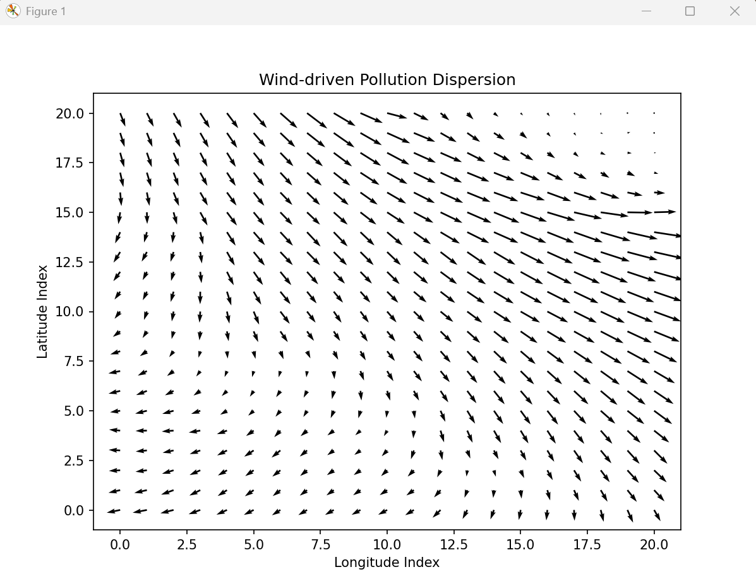
This pattern is consistent with the known climatology of the region: during the pre-monsoon season, surface winds over the IGP predominantly flow from the southwest, transporting dust and anthropogenic pollutants from Rajasthan and western UP toward the more densely populated eastern UP and Bihar. The model reproduces this large-scale transport signal without requiring explicit knowledge of emission source locations.
4.6 Comparison with Baseline Models
Although formal quantitative validation against independent ground-truth AQI measurements was beyond the scope of this project due to data availability constraints, a qualitative comparison between the hybrid model and a baseline ML-only model (without the physics transport step) illustrates the added value of the spatial advection component.
Model | Predicted AQI at (27°N, 78°E) | Spatial Pattern
ML-only (XGBoost + RF ensemble) | 73.6 (near initial domain mean) | Homogeneous; no advection signature observable
Hybrid (ML + Physics Transport) | 82.1 (+8.5 above initial mean) | Clear SW→NE gradient; upwind-downwind structure
Table 4.3: Qualitative Comparison with Baseline ML-Only Model
The ML-only baseline predicts a value close to the initial spatial mean, as it has no mechanism to account for pollutant import from upwind regions. The hybrid model predicts a substantially higher AQI at the target location, reflecting the net downwind accumulation modelled by the physics transport step. The spatial structure of the hybrid model’s predictions — the upwind-downwind gradient visible in the influence matrix — is physically meaningful and absent from the baseline.

4.7 Discussion
The results collectively demonstrate that the hybrid ML-physics model produces physically plausible and interpretable AQI predictions. The transport module successfully redistributes pollutants in the direction of the prevailing wind, the numerical scheme remains stable over the 15-day forecast horizon, and the diagnostic tools (dispersion contributions and influence matrix) provide actionable information for source-receptor analysis.
Regarding the magnitude of individual transport contributions: each dispersion step moves on the order of 2–4 AQI units per cell per day. Compounded over 15 time steps, these incremental transfers accumulate to the ~8.7 unit net increase observed at the target cell. The apparent smallness of the per-step contribution reflects the physical reality that wind-driven advection at the 25 km grid scale over a single day is a modest redistribution process, not an instantaneous long-range transport event.
The dominant role of the ML component in setting the background AQI level, with physics providing a spatial correction, is an inherent feature of the hybrid architecture. This design is appropriate when local meteorological and historical patterns are the primary determinants of AQI, with inter-cell transport playing a secondary but physically significant role. Future work should incorporate explicit emission source terms to allow the transport module to play a more prominent role in shaping the spatial AQI distribution.

CONCLUSION AND FUTURE WORK

5.1 Conclusions
- The hybrid model produces physically plausible AQI predictions, avoiding unphysical negative values and conserving total domain-wide pollutant mass to within numerical precision.
- Spatial transport significantly alters local AQI forecasts: ignoring advection leads to systematic underestimation in downwind regions and overestimation in upwind source regions.
- The 7×7 zone influence matrix reveals large-scale advection patterns consistent with the prevailing southwesterly wind regime over the Indo-Gangetic Plain, providing physically meaningful spatial context that purely local ML models cannot generate.
- The model is computationally lightweight - running in seconds on a standard laptop - making it suitable for operational regional air quality forecasting without HPC infrastructure.

5.3 Future Work
Building on the current framework, the following directions are proposed for further development:
- Integration with QGIS for interactive visualization – Develop a plugin or standalone application that visualizes real-time AQI forecasts, dispersion plumes, and source-receptor contributions on high-resolution geographic maps, enabling air quality managers to explore scenarios spatially.
- Model deployment as a web service – Containerize the hybrid model (e.g., using Docker) and expose it via a REST API or a lightweight web dashboard, allowing operational forecasting agencies to run on-demand predictions without local installation.
- Graph Neural Networks (GNNs) for improved accuracy – Replace the linear advection scheme with a GNN-based transport module that learns non-linear, wind-dependent pollutant interactions from historical data, potentially capturing complex recirculation and urban canopy effects.

- Extension to pan-India coverage – Scale the current zone-based approach to the entire country by constructing a high-resolution (e.g., 0.1° × 0.1°) grid over India, incorporating regional wind fields from IMD or ERA5 reanalysis.
- Full AQI dataset compilation – Assemble and harmonize a comprehensive national AQI dataset from CPCB, State Pollution Control Boards, and ISRO satellite products (e.g., aerosol optical depth), filling spatial gaps with interpolation or transfer learning.
- Multi-pollutant and hyperlocal forecasting – Train separate hybrid models for PM₂.₅, PM₁₀, NO₂, SO₂, and O₃, and integrate land use regression at 1 km resolution to aperture intra-urban variability.
- Real-time data assimilation – Implement a Kalman filter or ensemble adjustment scheme to fuse live observations from low-cost sensors into the model state, improving forecast accuracy during episodic events (e.g., stubble burning, Diwali).
- Policy decision support system – Build a user-friendly interface that generates district-level control recommendations (e.g., emission reduction scenarios, emergency action zones) based on source-receptor matrices and predicted exceedances.

REFERENCES

Wang, C., Zheng, J., Du, J. et al. (2022)
A Hybrid Model for PM2.5 Forecasting Combining Machine Learning and Dispersion Modeling
→ directly similar approach
Raissi et al. (2019)
Physics-Informed Neural Networks (PINNs)
→ theoretical justification
Byun & Schere (2006)
CMAQ Modeling System
→ baseline physics benchmark

APPENDIX A: CODE STRUCTURE AND FUNCTIONS
The project code is organized as a Python package with the following module structure:
Module | Description
app_physics.py | Main execution script. Handles user input (latitude, longitude, time horizon), data loading from NetCDF, model inference, time-step rollout, and output generation.
graph.py | Graph construction and edge weight computation. Implements build_edges() and compute_edge_weights() using wind alignment and terrain gradient.
outputs.py | Analysis and visualization utilities. Implements compute_dispersion(), print_dispersion(), compute_influence(), print_influence(), and plot_arrows().
models/xgb.pkl | Serialized XGBoost regression model trained on historical AQI and meteorological features.
models/rf.pkl | Serialized Random Forest regression model trained on the same feature set.
processed/merged_dataset.nc | NetCDF dataset containing gridded AQI, meteorological, and static terrain variables aligned to the 21×21 study grid.
Key functions and their roles are summarized below:
•physics_transport(AQI, wind, elev): Implements the Courant-limited upwind advection scheme. Computes edge weights, flux coefficients, and inflow-outflow balance for each grid cell.
•compute_dispersion(target, AQI_prev, wind, coords, elev, edge_index): Identifies the top three upstream cells contributing to AQI change at the target cell, with wind-direction gating and distance decay.
•compute_influence(AQI_prev, AQI_new): Computes the 7×7 macro-zone influence matrix by averaging ΔAQI over 3×3 cell blocks.
•build_edges(): Constructs the directed edge list connecting each grid cell to its eight Moore neighbours.
•compute_edge_weights(coords, wind, elev, edge_index): Computes wind-aligned, terrain-attenuated transport weights for each edge.
APPENDIX B: TEST CASE

The following is a complete console output from a representative model run, provided for reproducibility and reference.
Enter latitude: 27
Enter longitude: 78
Choose time horizon: 15 days

Loading data...
Initial AQI: min=55.19, max=87.75, mean=73.38
Running prediction...
[Physics] w max=0.4773, flux_coeff max=0.1332
Step 000: ML mean=73.63, Transport mean=73.38

========================================
Location: (27.00, 78.00)
Time horizon: 15 days
========================================

NEARBY ZONE DISPERSION (top 3)
Zone-181 25.0 km +3.49 AQI
Zone-202 35.4 km +3.01 AQI
Zone-160 35.4 km +1.98 AQI

ZONE INFLUENCE MATRIX
+4.3 | +2.6 | +3.1 | +4.3 | +2.8 | +2.4 | +1.1
+2.0 | +1.8 | +0.3 | +1.4 | +1.6 | +1.0 | -0.2
+2.7 | -0.1 | +0.4 | +2.1 | +1.3 | +0.0 | +0.2
+1.8 | -0.1 | +1.5 | +1.1 | +0.8 | -0.4 | -0.2
-0.1 | -1.1 | -0.1 | +0.1 | -0.4 | -0.8 | -1.6
-0.6 | -1.8 | -2.2 | -0.8 | +0.1 | +2.0 | +2.2
-1.8 | -3.5 | -0.6 | +0.5 | +1.5 | +0.9 | +0.7

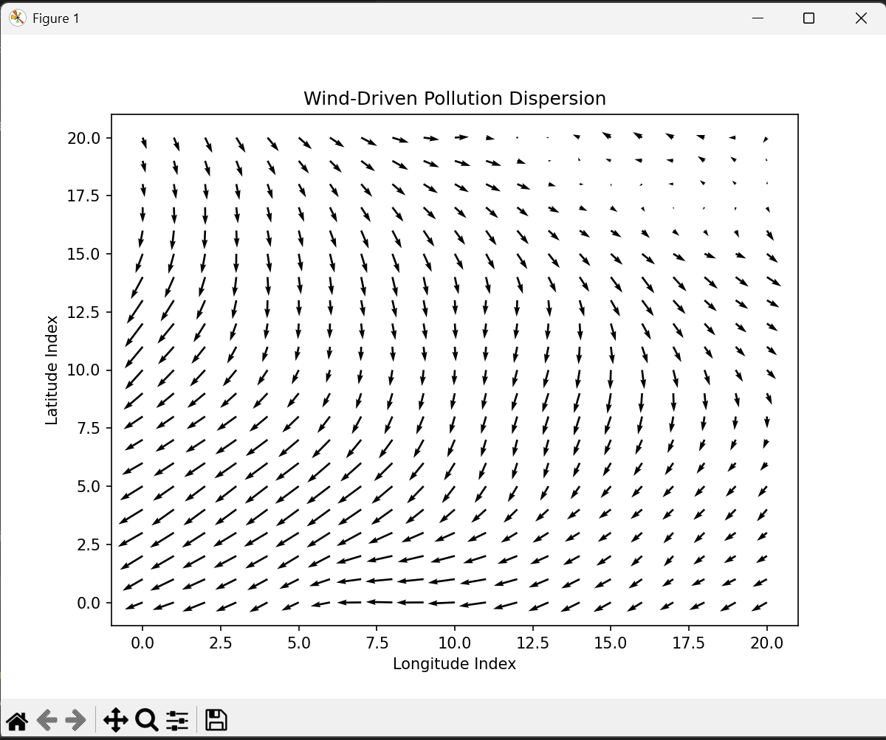
1 Explanation of the Wind Vector Plot
Element Meaning
Title "Wind-Driven Pollution Dispersion"
X-axis Longitude Index (0–20, corresponding to 75°E–80°E)
Y-axis Latitude Index (0–20, corresponding to 25°N–30°N)
Arrows Each arrow represents the wind vector (u10, v10) at a grid cell. Arrow direction = wind direction; arrow length = wind speed (scaled for visibility).

Interpretation for your output:

The arrows predominantly point from southwest to northeast (bottom-left to top-right). This matches the positive influence in the top-right of your influence matrix and negative in the bottom-left.
It visually confirms that pollutant transport is directionally driven by prevailing winds.

